The KPC IPO : Was It All Hype?

Introduction
On 9 March 2026, Kenya Pipeline Company listed on the Nairobi Securities Exchange at KES 9.00 per share. It was the largest IPO in East African history, raising KES 106.3 billion for the government.
The offer was oversubscribed by 105.7%. The Information Memorandum called it a “proud success story.” The Cabinet Secretary urged every Kenyan to participate.
But behind the headlines, independent analysts were quietly publishing valuations that told a very different story. Old Mutual Uganda said the shares were worth KES 4.61. Standard Investment Bank said KES 5.61. Other independents placed fair value as low as KES 3.28.
That is a gap of 38% to 64% below the IPO price.
So who was right? Was KES 9.00 a fair price, or was it a government exit dressed up as a national opportunity?
I rebuilt the valuation from scratch using the Information Memorandum, audited financials, and standard valuation methods. Here’s what I found.

The Red Flags
The post-mortem analysis revealed five key red flags, each building on the evidence established by the previous one.
Throughout this article, we’ll examine these findings individually, trace how they reinforce one another, and ultimately determine whether KPC’s KES 9.00 IPO price was justified by its fundamentals.

Background: What you were buying.

Kenya Pipeline Company is a regulated midstream monopoly. It owns and operates 1,342 kilometres of pipeline, 1.14 million cubic metres of storage, and a fibre optic network. It transports petroleum products from Mombasa to the hinterland and to landlocked neighbors: Uganda, Rwanda, South Sudan, and eastern DRC.
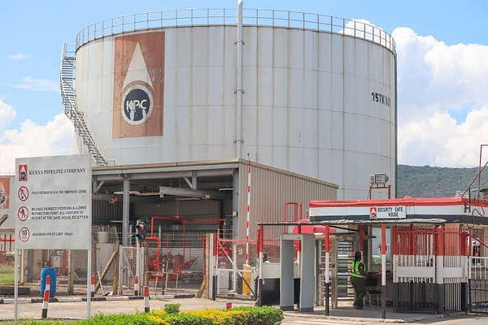Source: https://www.businessdailyafrica.com/bd/corporate/companies
On paper, the financials look strong. The business is profitable, cash-generative, and holds a quasi-monopoly. That sounds like a compelling investment.
But profitability is not the same as value creation. A company creates value only when it earns more than its cost of capital. And that is where the story turns.

Red Flag No. 1: KPC’s Historical Returns Fall Short of Its Cost of Capital.
Weighted Average Cost of Capital (WACC) is the minimum return a company needs to earn to make the money invested in it worthwhile for both its lenders and shareholders. Think of it as the cost of using other people’s money. If a company earns less than this, it may be destroying value instead of creating it.
I calculated the WACC based on the financials provided in the KPC IM and got a figure of 18.69%. That means KPC must earn 18.69% or more to satisfy it’s shareholders. Any proposed project should also earn a return at the same level or above to create value.
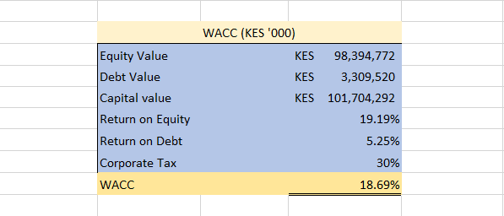
The first red flag comes from the historical financials themselves. On FY2025 numbers, KPC did not earn its cost of capital. Not even close.
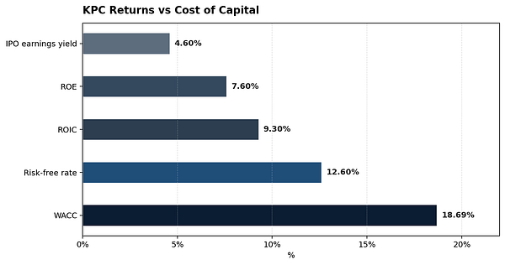
KPC earned an ROE of 7.6% and an ROIC of 9.3% in FY2025. Both are far below the company’s estimated WACC of 18.7%. The values are also below the Kenyan risk-free rate of 12.6%.
This matters because a company that earns below its cost of capital destroys value with every shilling reinvested. Growth becomes a liability, not an asset.
The IPO price implied a P/E of 21.8x. That is a growth multiple for a company that has not demonstrated value-creating growth.

Red Flag No. 2:The DCF Valuation Says Kes 1.70.
I built a discounted cash flow model using management’s own forecasts from the Information Memorandum. I used the following assumptions:
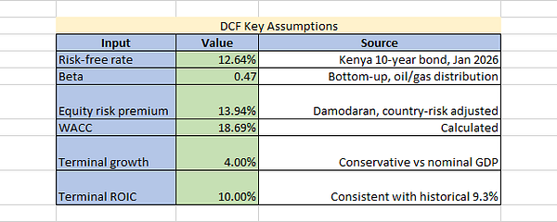
And this is how my DCF was structured:
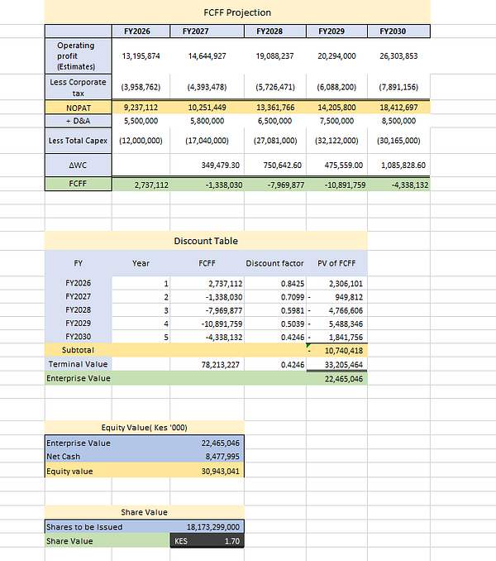
The second red flag: The model produces a value of KES 1.70 per share. That’s 81% below the IPO price of KES 9.00.
Why? The explicit-period cash flows are negative. KPC is spending KES 110 billion on new projects. The entire enterprise value comes from the terminal value and the terminal value depends on a company that has historically earned below its cost of capital.
A single DCF output however can be misleading. I decided to run a sensitivity test to see what share value range I got and that’s where the third red flag emerged, solidifying the second one.

Red Flag No. 3: The Sensitivity Test confirms Kes 9.00 is way high.
A sensitivity analysis test is a financial modeling technique that measures how changes in an independent input variable (like growth rate) affect a specific dependent output variable (our share value in this case).
I targeted Growth and Return on Invested Capital(ROIC) specifically in the test and these were my results:
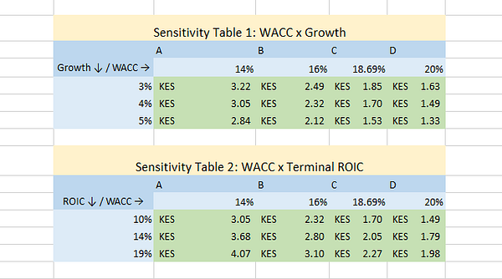
The third red flag: Across every share value cell, the share value never reached or came close to the IPO offer price: KES 9.00. Even if KPC earns its full cost of capital in perpetuity (the best-case scenario for a regulated monopoly) the value at base WACC is only KES 2.27.
At WACC = 18.69%, higher growth produces lower value. This is because ROIC (10%) is below WACC (18.69%). When a company earns less than its cost of capital, growth destroys value. This is a fundamental principle that the IPO pricing ignored.

Red Flag No. 4: Relative Valuation backs up the DCF.
DCF is not the only way to estimate a company’s value. I also used the valuation multiples of KPC’s regional peers to estimate what its shares could be worth.
By multiplying the peer median P/E ratio or EV/EBITDA multiple by KPC’s earnings per share (EPS), I calculated an implied share value. This provides a benchmark for comparison with the KES 9.00 IPO price: if the implied value is higher, the shares may be undervalued; if it is lower, they may be overvalued.
These are the focused peers I used in my relative valuation:
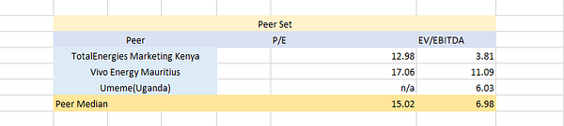
Note: No P/E ratio for Umeme( Uganda ) since it was loss making.
From the list, we got a P/E median of 15.02x and an EV/EBITDA multiple of 6.98x. Let’s see what implied value we get with the P/E median first:
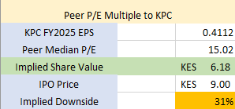
An implied value of only Kes 6.18, compared to the offer price of Kes 9.00.(31% to the downside). Old Mutual Investment Group Uganda’s P/E median was even more harsh coming in at 11x, giving an implied share value of Kes 4.52 which was 50% to the downside.
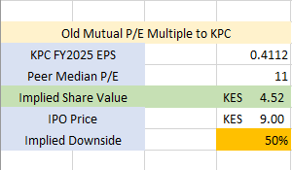
Hmm, maybe the EV/ EBITDA will tell a different story:
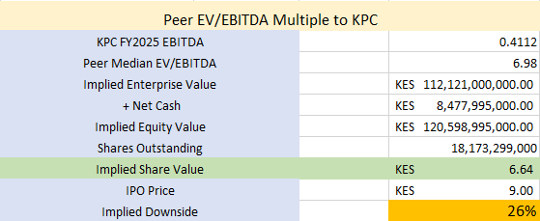
Fourth red flag: Still the same narrative. An implied value of Kes 6.64, 26% below the offer price. Every valuation approach used is singing the same song; The offer price was too high.
The relative valuation is higher than the DCF, which is normal and expected. Why? Relative valuation reflects what the market is currently paying for similar assets. It embeds market sentiment, liquidity, and the possibility that peers are also overvalued. The DCF reflects intrinsic value based on fundamentals. When the DCF is much lower than relative valuation, it often signals that the entire sector is expensive relative to fundamentals.

Red Flag No. 5: The Pricing Basis Was a Selling Bid.
The Information Memorandum justified the KES 9.00 price using an EV/EBITDA multiple of 8.1x. It claimed comparability with “regional and global infrastructure peers.”
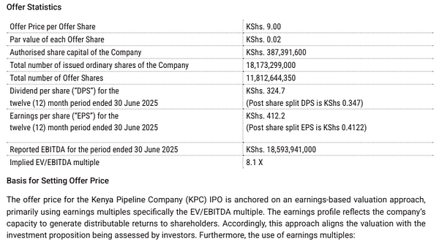Excerpt from IM Section 7
The Fifth red flag: The basis named no peers. It disclosed no peer multiples. It claimed “asset- and income-based crosschecks” but revealed none of their conclusions.
This is not a valuation analysis. It is a compliance narrative designed to justify a price that had already been decided. The peer median EV/EBITDA is approximately 6.0x. KPC’s implied 8.1x is a 35% premium. The Information Memorandum does not explain why KPC deserves that premium.

Valuation Summary
Every method produces a value below KES 9.00. The IPO price sits above the entire range.
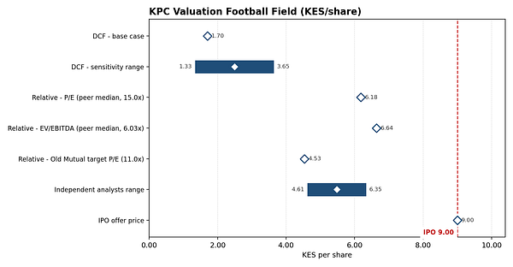
The closest approach is the EV/EBITDA method at KES 6.64, and even that is still 26% below the offer price.

The Verdict: Was it all hype?
The answer: Yes.
The IPO was priced at a premium to every reasonable valuation. The government sold 65% of a company that earns below its cost of capital at a price that implied it would earn far above it.
How come the offer was oversubscribed by 105.7%?
The oversubscription came from institutions and from Uganda’s national oil company — not from the Kenyan public the IM was written for. Retail investors largely stayed away.
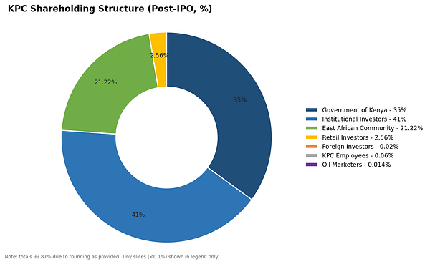KPC Shareholding Data as at March 4th, 2026
This does not mean KPC is a bad company. It is a strategic national asset with stable cash flows and a quasi-monopoly. But a good company can still be a poor investment choice at the wrong price.
What would have happened if you invested your money at the time?
Stay tuned and follow for part B where we explore this.

Disclaimer
This article is for educational and informational purposes only. It is not investment advice, a recommendation, or a solicitation to buy, sell, or hold any security. Nothing in this article should be construed as financial, legal, tax, or accounting advice. Readers should consult a licensed financial adviser before making any investment decision.
The author does not hold, and has not held, any position in Kenya Pipeline Company PLC, its subsidiaries, or any related securities at the time of writing. No compensation has been received from any party for the production of this analysis.
This analysis relies on publicly available information, principally the Kenya Pipeline Company Information Memorandum dated 17 January 2026, the company’s audited financial statements for the five years ended 30 June 2025, interim financial statements for the period ended 30 September 2025, and publicly available market data. While reasonable care has been taken to verify the accuracy of the information, the author makes no representation or warranty, express or implied, as to its accuracy, completeness, or reliability.
The valuation presented in this article is based on assumptions, estimates, and forecasts that are inherently uncertain. Actual results may differ materially. The discounted cash flow model, relative valuation, and sensitivity analyses are illustrative and depend on inputs — including the risk-free rate, equity risk premium, beta, terminal growth rate, and terminal return on invested capital — that are subject to debate and may not reflect future conditions. Small changes in these assumptions can produce materially different valuations. The valuation should be read as a range of possible outcomes, not a precise forecast.
To the fullest extent permitted by law, the author disclaims any liability for any loss, damage, cost, or expense arising directly or indirectly from the use of, or reliance on, any information contained in this article.

Relevant Sources
Boost To Ruto As Kenya Pipeline IPO Is Oversubscribed
Kenya Pipeline Company (KPC) has announced the Initial Public Offer (IPO), marking a historic milestone in opening up…thekenyatimes.com

